Part 1: Docker Networking
Total marks: 50 Overview:
This part will test your understanding of Docker networking and how to use it to connect Docker containers. You will be required to perform several tasks and document your findings in a README.md file on your GitHub repository
. Instructions:
- Create a new Docker network named "my_network" using the bridge driver. (2 marks)
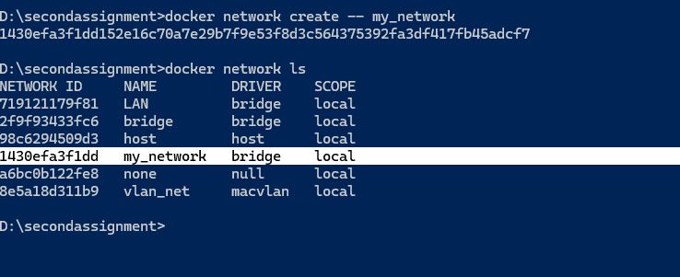

- Create a new Docker container using the "nginx" image and connect it to the "my_network" network. Name the container "nginx_container". (4 marks)
>docker run –d –p 8080:80 --network my_network --name nginxServer nginx
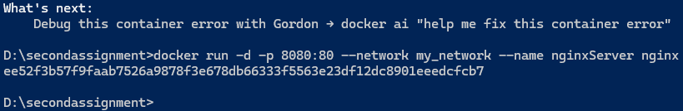

- ● Verify that the "nginx" default page is accessible on your host machine at http://localhost:8080. (2 marks)
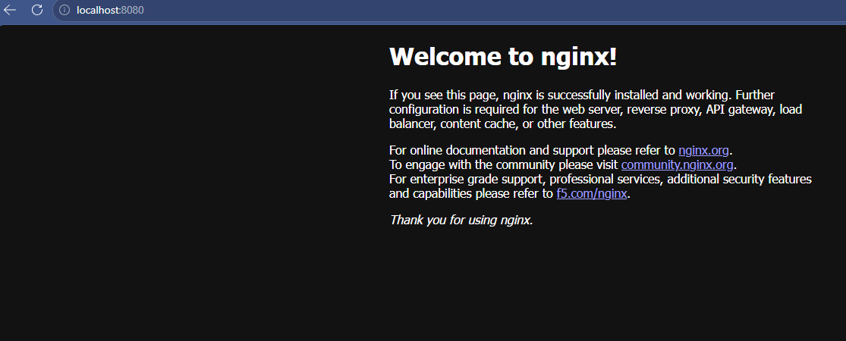

- ● Create a new Docker container using the "httpd" image and connect it to the "my_network" network. Name the container "httpd_container". (4 marks)
>docker run –d –p 8081:80 –network my_network –name httpd_container httpd
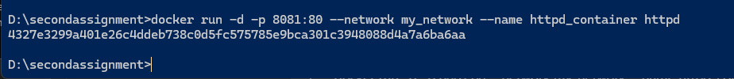
- ● Verify that the "httpd" default page is accessible on your host machine at http://localhost:8081. (2 marks)
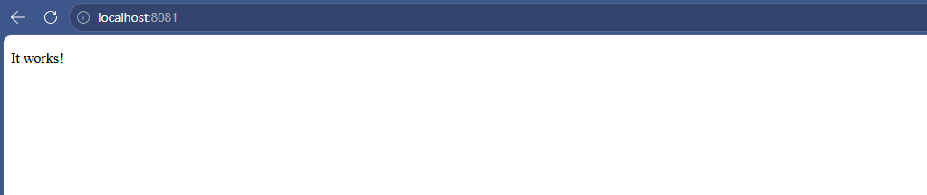

- ● Use the "docker network inspect" command to display information about the "my_network" network. Document your findings in the README.md file. (4 marks)
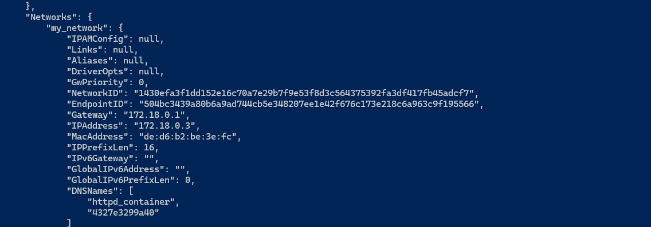

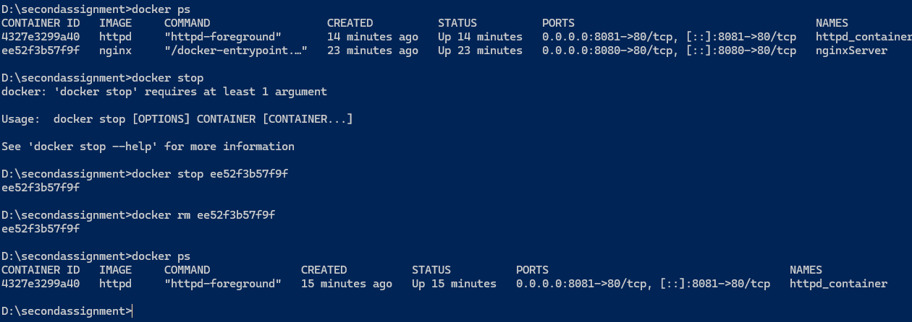
- ● Stop and remove the "nginx_container" container. (2 marks)

- ● Create a new Docker container using the "nginx" image and connect it to the "my_network" network. Name the container "nginx_container_2". (4 marks) ●

- Verify that the "nginx" default page is accessible on your host machine at http://localhost:8082. (2 marks)
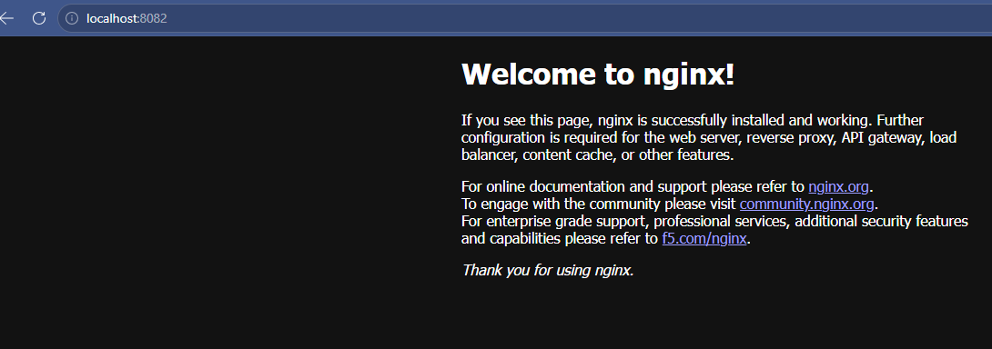

- ● Use the "docker container ls" command to display information about all running containers. Document your findings in the README.md file. (4 marks)
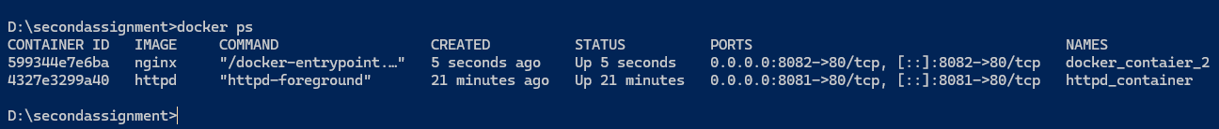

- Stop and remove all containers. (2 marks)

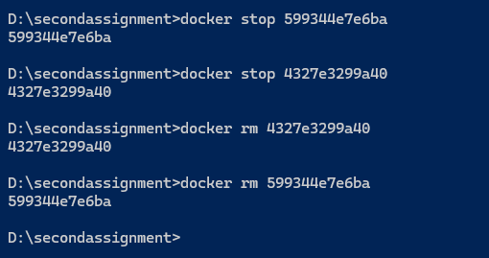

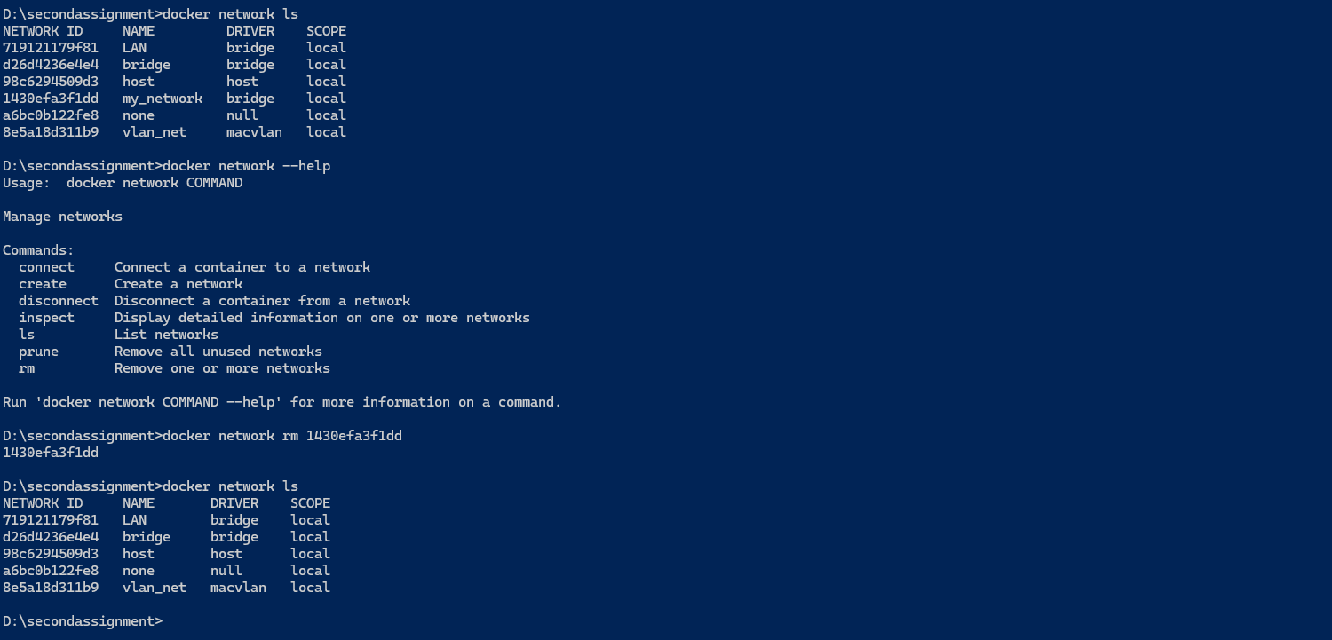
- Cleanup: Remove the "my_network" network. (2 marks)

Network removed , you can view the above nework in first list and command executed and then in last list the network removed
- ● Create a README.md file and document your findings for each command. For each command, provide a brief description of what it does, followed by the output and logs generated by the command. Ensure that the README.md file is well-organized, easy to read, and contains all necessary information. (18 marks)
This doc contain all necessary information, commands and its output above.

- ● Push the codebase for the sample application to your GitHub repository (create a n

